Guide for Indicators

Regular Projects

TAKE NOTE
THIS GUIDE IS DESIGNED TO ASSIST POTENTIAL APPLICANTS FOR REGULAR PROJECTS FINANCED BY THE INTERREG VI-A NEXT ROMANIA-REPUBLIC OF MOLDOVA PROGRAMME IN SELECTING AND MEASURING CORRECTLY THE PROGRAMME INDICATORS WHILE FILLING IN THE APPLICATION FORM. THE GUIDE IS NOT A STAND ALONE DOCUMENT AND IT SHOULD BE USED TOGETHER WITH THE GUIDELINES FOR GRANT APPLICANTS AND ITS ANNEXES AND JEMS.

General INFORMATION

Definitions
'Output indicator' means an indicator to measure the specific deliverables of the intervention. - CPR Article 2
'Result indicator' means an indicator to measure the effects of the interventions supported, with particular reference to the direct addressees, population targeted or users of infrastructure. – CPR Article 2

'Target' means a pre-agreed value to be achieved at the end of the eligibility period in relation to an indicator included under a specific objective. - CPR Article 2

'Milestone' means an intermediate value to be achieved at a given point in time during the eligibility period in relation to an output indicator included under a specific objective. – CPR Article 2

‘Regular projects’ are projects with an investment component of minimum 60% of the value of project.

ROMANIA – REPUBLIC OF MOLDOVA INTERREG NEXT PROGRAMME STRATEGY AND INTERVENTION LOGIC FOR REGULAR PROJECTS

The Romania-Republic of Moldova Programme finances regular projects under Priorities 1, SO 1.1, So 1.2, Priority 2 SO 2.1, SO 2.2, SO 2.3 and Priority 3, SO3.2. In drafting the applications, the project intervention logic should be linked to the programme intervention logic.

Project intervention logic
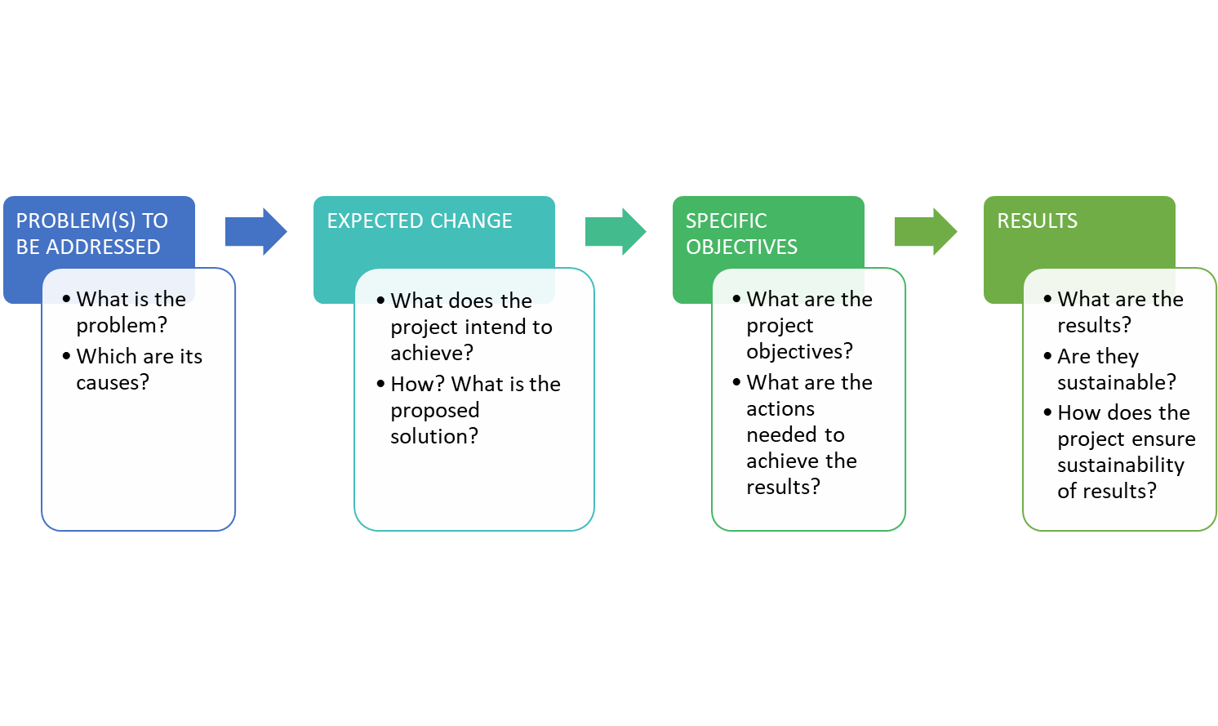

The project intervention logic is described in the graphic above with its main stages. In drafting the application, the most important issue to consider is that the project intervention logic must mirror the programme intervention logic and support its achievement. The graphic below is meant to aid this process.

Programme- Project Intervention Logic

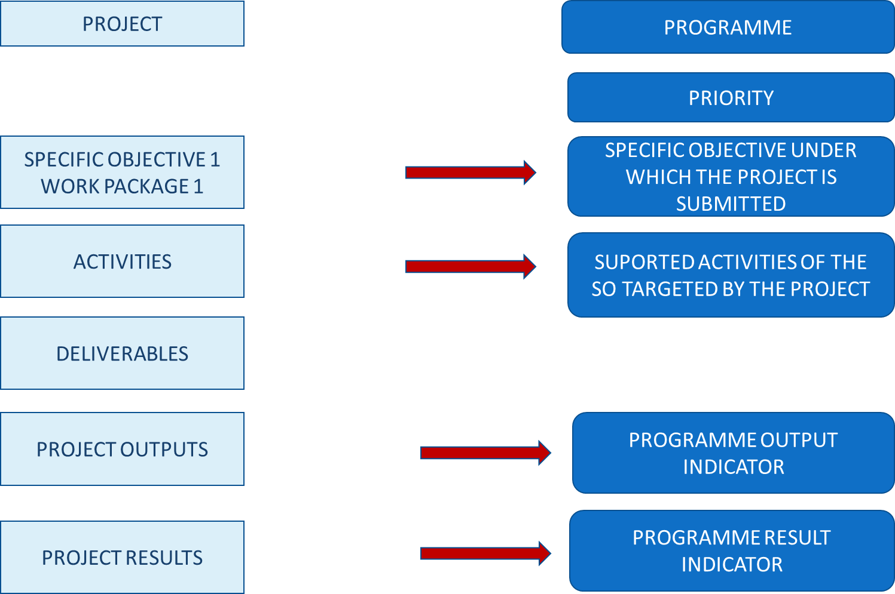

Depending on the Programme Specific Objective under which the project will be submitted, you have to choose the pair/s of output indicators (RCO) and result indicators (RCR/PSR) the project contributes to. For regular projects the overview of the indicators to be addressed is provided in the table below:

Priority | Specific Objective | Output indicators | Result indicators | Mandatory/  recomended
PRIORITY 1: GREEN COMMUNITIES | 1.1 Promoting climate change adaptation and disaster risk prevention and resilience, taking into account eco-system based approaches | RCO 24- Investments in new or upgraded disaster monitoring, preparedness, warning and response systems against natural disasters | PSR1- Population benefiting from protection measures against climate related natural disasters | mandatory
 |  | RCO 83: Strategies and action plans jointly developed | RCR79: Joint strategies and action plans taken up by organisations | recommended
 |  | RCO 87 - Organisations cooperating across borders | RCR 84 - Organisations cooperating across borders after project completion | mandatory
 |  | RCO 81 - Participations in joint actions across borders | RCR 85- Participations in joint actions across borders after project completion | recommended
 | 1.2. Enhancing protection and preservation of nature biodiversity and green infrastructure, including in urban areas, and reducing all forms of pollution | RCO 83: Strategies and action plans jointly developed | RCR79: Joint strategies and action plans taken up by organisations | recommended
 |  | RCO 84: pilot actions developed jointly and implemented in projects | RCR79: Joint strategies and action plans taken up by organisations | mandatory
PRIORITY 2: SOCIAL DEVELOPMENT ACROSS BORDERS | 2.1 Improving equal access to inclusive and quality services in education, training and lifelong learning through developing accessible infrastructure, including by fostering resilience for distance and on-line education and training | RCO 67 - Classroom capacity of new or modernised education facilities | RCR 71 - Annual users of new or modernised education facilities | mandatory
 |  | RCO 87 - Organisations cooperating across borders | RCR 84 - Organisations cooperating across borders after project completion | mandatory
 |  | RCO 116 – Jointly developed solutions | RCR 104 – Solutions taken up or up-scaled | recommended
 | 2.2 Ensuring equal access to health care and fostering resilience of health systems, including primary care, and promoting the transition from institutional to family-based and community- based care | RCO 87 - Organisations cooperating across borders | RCR 84 - Organisations cooperating across borders after project completion | mandatory
 |  | RCO 69 Capacity of new or modernised health care facilities | RCR 73 Annual users of new or modernised health care facilities | mandatory
 |  | RCO 81 - Participations in joint actions across borders | RCR 85 - Participations in joint actions across borders after project completion | recommended
 | 2.3. Enhancing the role of culture and sustainable tourism in economic development, social inclusion and social innovation | RCO 87 - Organisations cooperating across borders | RCR 84 - Organisations cooperating across borders after project completion | mandatory
 |  | RCO 83 - Strategies and action plans jointly developed | RCR 79 - Joint strategies and action plans taken up by organisations | recommended
 |  | RCO 77 - number of cultural and tourism sites supported | RCR 77 - visitors of cultural and tourism sites supported | mandatory
3. Cooperation across borders | 3.2.Border crossing management | RCO 81 - Participations in joint actions across borders | RCR 85 - Participations in joint actions across borders after project completion | mandatory
 |  | RCO 83 - Strategies and action plans jointly developed | RCR 79 - Joint strategies and action plans taken up by organisations | recommended

General considerations
- One project can address one or more output and results indicators. In choosing the indicators that best reflect the objectives and outputs of your project please take note that some of the indicators are mandatory for regular projects, as listed above. Failing to address them means that the application does not properly contribute to the achievement of the programme’s output and results and will not be selected for financing!
- Please read carefully the descriptions and guidance notes for each indicator and please note that, for some result indicators, the reporting period could be even one year after project completion;
- In the process of reporting on indicators, the lead partner is the one bearing the responsibility for monitoring and then reporting to the programme structures. In doing this, the lead partner should collect and consolidate partner data against project activities, outputs and results.
- In monitoring and reporting on the achievement of indicators, the lead partner should take the necessary measures in order to avoid double counting and to ensure that there is consistency between the application, implemented activities and reported outputs and results.

Project Outputs and Results vs Output and Result Indicators

The starting point for the project intervention logic should be the need it aims to fulfill. Leading from this, the activities are generated, the specific deliverables and what the project outputs and results will be. These outputs and results need to be properly described in the application form (Section C4.1 Work Plan).
Please note that a deliverable is not an output. A deliverable is the documentation of a certain activity (e.g a workshop is a deliverable, while organizations cooperating or people participating in the workshop are outputs and correspond to programme indicators). The deliverables, as presented also in Figure 2 above, don’t have a correspondent in programme intervention logic and are specific to the project.
The outputs are the main “products” of the project and they reflect its most important outcomes. More activities could contribute to the achievement of one output and more than one project output can contribute to the achievement of a programme output indicator.
TAKE NOTE
For each specific objective there are mandatory and recommended indicators. Failing to address the mandatory indicators will lead to the rejection of the project proposal!

Programme indicators: definitions and guidance

PRIORITY 1: GREEN COMMUNITIES

Specific objective 1.1: Promoting climate change adaptation and disaster risk prevention and resilience, taking into account eco-system based approaches

Specific Objective | Output Indicators | Result Indicators | Mandatory/reccommended
1.1. Promoting climate change adaptation an disaster risk prevention… | RCO 87 - Organisations cooperating across borders | RCR 84 - Organisations cooperating across borders after project completion | Mandatory
 | RCO 83 - Strategies and action plans jointly developed | RCR 79 - Joint strategies and action plans taken up by organisations | Reccommended
 | RCO 81 - Participations in joint actions across borders | RCR 85 - Participations in joint actions across borders after project completion | Reccommended
 | RCO 24- Investments in new or upgraded disaster monitoring, preparedness, warning and response systems against natural disasters | PSR 1- Population benefiting from protection measures against climate related natural disasters | Mandatory

RCO 87 - Organisations cooperating across borders
This indicator covers all the types of actions proposed under the specific objective 1.1.
The indicator counts the organisations cooperating formally in supported projects. The organisations counted in this indicator are the legal entities (project partners) involved in project implementation. The cooperation should be based on a structured agreement between project participants (Partnership Agreement).
! The indicator covers all types of activities: investments in infrastructure and endowment, trainings and elaboration of joint strategies and tools!
! Timeframe for measurement: upon project completion!
RCR 84 - Organisations cooperating across borders after project completion

The indicator counts the organisations cooperating across borders after the completion of the supported projects. The organisations are legal entities involved in project implementation, counted within RCO87. The cooperation concept should be interpreted as having a a formal agreement of the entities to continue cooperation, after the end of the supported project.
A cooperation agreement should be signed during project implementation and the purpose of the project should imply the need for maintaining the cooperation over a longer period of time than the implementation period.
Not all project partners need to continue the cooperation, only one partner/organization from each state is needed.
The timeframe for measurement for the achievement of this indicator will be during project implementation or one year after project completion. Intermediate values can be collected for reporting purposes also during projects implementation.
The sustained cooperation does not have to cover the same topic as addressed by the completed project.
Multiple counting will be removed at the level of the specific objective. An organization is considered once regardless how many times it receives support from operations in the same specific objective. In case the project envisages the conclusion of multiple cooperation agreements, each organisation will be counted by the programme structures only once at the level of the programme, no matter how many cooperation agreements it signs. Therefore, when reporting on this result indicator at project level, the lead partner will mention not only the number of unique organisations that concluded cooperation agreements, but it will also clearly identify these organisations.

RCO 83 - Strategies and action plans jointly developed
This output indicator covers the types of actions: joint operational plans/procedures for risk prevention and management, elaborating updated joint operational plans and procedural framework for efficient management and deployment of joint interventions, hydrological monitoring of rivers, water temperature, precipitation measurements, ice regime; strengthen the banks of rivers, canals, the condition of dams, afforestation of river banks; prevention activities for the elimination of erosions.
The indicator counts the number of joint strategies or action plans developed by supported projects. A jointly developed strategy aims at establishing a targeted way to achieve a goal oriented process in a specific domain. An action plan translates an existing jointly developed strategy into actions.
Jointly developed strategy or action plan imply the involvement of organizations from both countries in the drafting process of the strategy or action plan.
! If the strategy or action plan covers several specific objectives, it should be counted only once for the dominant specific objective.
! Projects aiming to implement specific jointly developed strategies or action plans, previously developed, should not be reported for this output indicator.

RCR 79 - Joint strategies and action plans taken up by organisations
This indicator counts the number of joint strategies and action plans (not individual actions) adopted and implemented by organisations during or after the project completion. At the time of reporting this indicator, the implementation of the joint strategy or action plan need not to be completed but effectively started.
! The organisations involved in take-up may or may not be direct participants in the supported project!
It is not necessary that all actions identified are taken-up for a strategy/action plan to be counted in this context.
The value reported should be equal to or less than the value for "RCO83 Strategies and action plans jointly developed.
! If a strategy or action plan covers several specific objectives, it should be counted only for the dominant specific objective!

RCO 81 - Participations in joint actions across borders
This output indicator covers the types of actions: joint trainings for climate change adaptation and risk prevention and management, awareness campaigns.
The indicator counts the number of participations in joint actions across borders implemented in the supported projects. Participations should be understood as the number of persons attending a joint action across borders - e.g. citizens, volunteers, students, pupils, public officials, etc. and are counted for each joint action organised on the basis of attendance lists or other relevant means of quantification.
! A joint action is considered as the action organised with the involvement of organizations from both countries (preparation, implementation, etc.).
! Participations in public events organized in supported projects will not be counted in this indicator.
! Participations in events related to project management or other internal project meetings will not be counted under this indicator.
! Participations, not participants are reported and this will be done based on attendance lists or other relevant means of quantifications. This means that a person can participate in multiple events and the participations will be counted.
! This indicator also adds up trainings (but with no certificate of completion or a record confirming the completion of the training).

RCR 85 - Participations in joint actions across borders after project completion

This result indicator should be selected in relation to the output indicator RCO81 - Participations in joint actions across borders.
In order to measure this change, only data related to RCO - 81 output indicator will feed into the result indicator.
The indicator counts the number of participations in joint actions across borders after the completion of the project, organised by all or some of the former partners/beneficiaries, as a continuation of cooperation. Joint actions across borders could include, for instance, exchange activities or exchange visits organized with participants from the two countries of the programme area.
The measurement unit is Participations (i.e. number of persons attending a joint action across border) and should be counted for each joint action organised on the basis of attendance lists or other relevant means of quantification.
! For the definition of this indicator, the joint action includes training schemes!
! Timeframe for measurement: one year after project completion. Intermediate values can be collected for reporting purposes also during projects implementation!

RCO 24 - Investments in new or upgraded disaster monitoring, preparedness, warning and response systems against natural disasters
The indicator measures the value of investments in projects.
Given the specific risk profile of the Programme area, floods and fires are likely to be among the main natural threats affecting the territory, directly associated with climate change. Other risks include coastal erosion and landslides, fires caused by draughts and high temperatures etc.
The indicator is intended to observe progress in respect to carrying out the projected investments in relation to natural disasters.
! Timeline for measuring this indicator is upon completion of output in the supported project!

PSR 1 - POPULATION BENEFITING FROM PROTECTION MEASURES AGAINST CLIMATE RELATED NATURAL DISASTERS
Data will be collected from the projects using the electronic monitoring system and the contribution to this indicator’s target will be measured upon completion of output in the supported project.
! Measurement unit for this programme specific result indicator is “persons”. Only population residing in the programme area will be counted for this indicator!

! Timeline for measurement is upon completion of output in the supported project!

Specific objective 1.2

Enhancing protection and preservation of nature biodiversity and green infrastructure, including in urban areas, and reducing all forms of pollution

Specific Objective | Output Indicator | Result Indicator | Mandatory/  Recommended
1.2. Enhancing protection and preservation of nature biodiversity and green infrastructure, including in urban areas | RCO 83 - Strategies and action plans jointly developed | RCR 79 - Joint strategies and action plans taken up by organisations | Recommended
 | RCO 84 - Pilot actions developed jointly and implemented in projects |  | Mandatory

RCO 83 - Strategies and action plans jointly developed
This Interreg Specific common output indicator covers the types of actions: drafting common management plans/procedures for protected areas; assessment, protection and improvement of existing ecosystems; awareness campaigns for the protection and eco-safe tourism promotion within protected areas.
The indicator counts the number of joint strategies or action plans developed by supported projects. A jointly developed strategy aims at establishing a targeted way to achieve a goal oriented process in a specific domain. An action plan translates an existing jointly developed strategy into actions.
Jointly developed strategy or action plan implies the involvement of organizations from both countries in the drafting process of the strategy or action plan. If a project includes any of the activities listed above, or similar ones, it should also select this output indicator and its correspondent result indicator.

! If the strategy or action plan covers several specific objectives, it should be counted only once for the dominant specific objective.
! Projects aiming to implement specific jointly developed strategies or action plans, previously developed should not be reported for this output indicator, but for RCO 84 (provided that the envisaged activities fulfill the specific requirements set for this output indicator).
! Projects aiming to both develop and implement pilot actions should be reported under RCO84.
! Timeframe for measurement of programme indicator: upon project completion.

RCO84 Pilot actions developed jointly and implemented in projects
This output indicator covers the following actions: assessment, protection and improvement of existing ecosystems (research activities, inventory of resources, protection of endangered species, eradication of invasive species, afforestation etc.); urban green infrastructure.
The indicator counts the pilot actions developed jointly and implemented by supported projects. The scope of a jointly developed pilot action could be to test procedures, new instruments, tools, experimentation or the transfer of practices. In order to be counted by this indicator,
- the pilot action needs not only to be developed, but also implemented within the project
and
- the implementation of the pilot action should be finalised by the end of the project.
! Jointly developed pilot action implies the involvement of organizations from both participating countries in its implementation.
! Pilot actions don’t cover actions like trainings, meetings events.
! Timeframe for measurement of programme indicator: upon project completion.

RCR 79 - Joint strategies and action plans taken up by organisations
This indicator counts the number of joint strategies and action plans (not individual actions) adopted and implemented by organisations during or after the project completion as well as the number of pilot actions. At the time of reporting this indicator, the implementation of the joint strategy or action plan need not to be completed but effectively started.
! The organisations involved in take-up may or may not be direct participants in the supported project.
It is not necessary that all actions identified are taken-up for a strategy/action plan to be counted in this context.
The value reported should be equal to or less than the value for "RCO83 Strategies and action plans jointly developed cummulated with the value of RCO 84 Pilot Actions developed jointly and implemented in projects.
! If a strategy or action plan covers several specific objectives, it should be counted only once for the dominant specific objective.

! The measurement of the indicator should be done one year after project completion

PRIORITY 2: SOCIAL DEVELOPMENT ACROSS BORDERS

Specific objective 2.1

Improving equal access to inclusive and quality services in education, training and lifelong learning through developing accessible infrastructure, including by fostering resilience for distance and on-line education and training

Specific Objective | Output Indicator | Result Indicator | Mandatory/ reccommended
2.1. Improving equal access to education | RCO 67 - Classroom capacity of new or modernised education facilities | RCR 71 - Annual users of new or modernised education facilities | Mandatory
 | RCO 87 - Organisations cooperating across borders | RCR 84 - Organisations cooperating across borders after project completion | Mandatory
 | RCO 116 – Jointly developed solutions | RCR 104 – Solutions taken up or up-scaled | Recommended

RCO67 Classroom capacity of new or modernised education facilities

The indicator covers the following types of activities: construction/rehabilitation/modernisation of educational infrastructure; equipment endowment of education institutions (schools, universities, libraries).

Classroom capacity should be understood in terms of maximum number of pupils/students who can be enrolled in and use the education facilities. Classroom capacity should be calculated in accordance with national legislation, but it should not include teachers, parents, auxiliary personnel or other persons who may use the facilities too. The average value of reference for classroom capacity for both countries is of 25 students. In the future, the values might change, depending on national legislation, therefore the reporting will consider the reference in force at that specific time.

! Education facilities, such as schools, can be newly built or modernised.

! Modernisation does not include energy renovation or maintenance and repairs.

RCR 71 Annual users of new or modernised education facilities
The indicator counts the annual number of unique registered pupils/ students using the education facility supported.
! The indicator does not cover teachers, parents, auxiliary personnel or any other persons who may use the facility too!
! The indicator covers education facilities such as schools that are newly built or modernised, and modernisation does not include energy renovation or maintenance and repairs!
Timeframe for measurement: for achieved values, the calculation should be carried out ex post based on the number and size of groups of pupils/students using the facility at least once during the year after the completion of the intervention. The project should indicate the target aimed to be achieved.

RCO 87 - Organisations cooperating across borders
This output indicator covers all the types of actions proposed under the specific objective 2.1.
The indicator counts the organisations cooperating formally in supported projects, including small projects (projects of a limited financial volume). The organisations counted in this indicator are the legal entities (project partners) involved in project implementation. The cooperation should be based on a structured agreement between project participants (Partnership Agreement).
! The indicator covers all types of interventions: infrastructure, endowment, trainings and elaboration of joint strategies and tools.
! Timeframe for measurement: upon project completion!

RCR 84 - Organisations cooperating across borders after project completion
The indicator counts the organisations cooperating across borders after the completion of the supported projects. The organisations are legal entities involved in project implementation, counted within RCO87. The cooperation concept should be interpreted as having a statement that the entities have a formal agreement to continue cooperation, after the end of the supported project.
A cooperation agreement should be signed during project implementation and the purpose of the project should imply the need for maintaining the cooperation over a longer period of time than the implementation period.
Not all project partners need to continue the cooperation, only one partner from each state is needed.
The timeframe for measurement for the achievement of this indicator will be during project implementation or up to one year after project completion. Intermediate values can be collected for reporting purposes also during projects implementation.
The cooperation agreements may be established during the implementation of the project or within one year after the project completion.
The sustained cooperation does not have to cover the same topic as addressed by the completed project.

RCO 116 – JOINTLY DEVELOPED SOLUTIONS
This output indicator covers activities such as development of joint educational tools, e-solutions, programs, networks; joint actions in the field of education (strategies, trainings, workshops, exchange of experience etc.) proposed under the specific objective 2.1.
The indicator counts the number of jointly developed solutions from joint pilot actions implemented by supported projects. In order to be counted in the indicator, an identified solution should include indications of the actions needed for it to be taken up or to be upscaled.
! The indicator covers all types of interventions: infrastructure, endowment, trainings and elaboration of joint strategies and tools.
! Timeframe for measurement: upon project completion!
! In order to avoid double counting, the solutions relevant for this indicator should not have the main topics linked to administrative or legal frameworks.

RCR 104 - SOLUTIONS TAKEN UP OR UP-SCALED BY ORGANISATIONS
The indicator counts the number of solutions, other than legal or administrative solutions, that are developed by supported projects and are taken up or up scaled during the implementation of the project or within one year after project completion. The organisation adopting the solutions developed by the project may or may not be a participant in the project. The uptake / up-scaling should be documented by the adopting organisations in, for instance, strategies, action plans etc.
A cooperation agreement should be signed during project implementation and the purpose of the project should imply the need for maintaining the cooperation over a longer period of time than the implementation period.
The timeframe for measurement for the achievement of this indicator will be during project implementation or up to one year after project completion.

Specific objective 2.2:

(v) Ensuring equal access to health care and fostering resilience of health systems, including primary care, and promoting the transition from institutional to family-based and community- based care

Specific Objective | Output Indicator | Result Indicator | Reccommended/ Mandatory
2.2. Ensuring equal access to healthcare | RCO 87 - Organisations cooperating across borders | RCR 84 - Organisations cooperating across borders after project completion | Mandatory
 | RCO 69-Capacity of new or modernized health care facilities | RCR 73- Annual users of new or modernized health care facilities | Mandatory
 | RCO 81 – Participations in joint actions across borders | RCR 85 - Participations in joint actions across borders after project completion | Recommended

RCO 87 - Organisations cooperating across borders
This output indicator covers all the types of actions proposed under the specific objective 2.2.
The indicator counts the organisations cooperating formally in supported projects. The organisations counted in this indicator are the legal entities (project partners) involved in project implementation. The cooperation should be based on a structured agreement between project participants (Partnership Agreement).
! The indicator covers all types of investments: infrastructure, endowment, trainings and elaboration of join strategies and tools.
! Timeframe for measurement: upon project completion!

RCR 84 - Organisations cooperating across borders after project completion

The indicator counts the organisations cooperating across borders after the completion of the supported projects. The organisations are legal entities involved in project implementation, counted within RCO87. The cooperation concept should be interpreted as having a statement that the entities have a formal agreement to continue cooperation, after the end of the supported project.
A cooperation agreement should be signed during project implementation and the purpose of the project should imply the need for maintaining the cooperation over a longer period of time than the implementation period.
Not all projects need to continue the cooperation, but each project should contribute to at least one result indicator.
The timeframe for measurement for the achievement of this indicator will be during project implementation or up to one year after project completion. Intermediate values can be collected for reporting purposes also during projects implementation.
The cooperation agreements should be established during the implementation of the project or within one year after the project completion.
The sustained cooperation does not have to cover the same topic as addressed by the completed project.
Multiple counting will be removed at the level of the specific objective. An organization is considered once regardless how many times it receives support from operations in the same specific objective. In case the project envisages the conclusion of multiple cooperation agreements, each organisation will be counted by the programme structures only once at the level of the programme, no matter how many cooperation agreements it signs. Therefore, when reporting on this result indicator at project level, the lead partner will mention not only the number of unique organisations that concluded cooperation agreements, but it will also clearly identify these organisations.

RCO 69 - Capacity of new or modernised health care facilities
This is an indicator counting to the maximum annual number of persons that can be served by the new or modernised health care facility at least once during a period of one year. Healthcare facilities include hospitals, clinics, outpatient care centers, specialized care centres etc.
The indicator will be calculated only in relation to the regular projects envisaging infrastructure construction, rehabilitation and modernisation and large equipment endowment.
! Modernisation does not include energy renovation or maintenance and repairs.
! Timeframe for measurement: upon project completion!

RCR 73 - Annual users of new or modernised health care facilities

This indicator sums up the number of patients served by the new or modernised health care facility during the year after the completion of the intervention. One individual can be counted more than once if using facilities multiple times.
Healthcare facilities include hospitals, clinics, outpatient care centres, specialized care centres etc.
Applicants need to indicate in the application form the registered patients served at least once by the health care facility during the year before the start of the intervention. This can be zero for new facilities.
! Timeline for measuring the value of this indicator is one year starting with the time when the new or modernised health care facility becomes operational.

Specific objective 2.3: Enhancing the role of culture and sustainable tourism in economic development, social inclusion and social innovation

Specific Objective | Output Indicator | Result Indicator | Reccommended/ Mandatory
2.3. Enhancing the role of culture and sustainable tourism in economic development, social inclusion and social innovation | RCO 87 - Organisations cooperating across borders | RCR 84 - Organisations cooperating across borders after project completion | Mandatory
 | RCO 83 – Strategies and action plans jointly developed | RCR 79 – Joint strategies and action plans taken up by organisations | Recommended
 | RCO 77 Number of cultural and tourism sites supported | RCR 77 - Visitors of cultural and tourism sites supported | Mandatory

RCO 87 - Organisations cooperating across borders
This output indicator covers all the types of actions proposed under the specific objective 2.3.
The indicator counts the organisations cooperating formally in supported projects. The organisations counted in this indicator are the legal entities (project partners) involved in project implementation. The cooperation should be based on a structured agreement between project participants (Partnership Agreement).
! The indicator covers all types of investments: infrastructure, endowment, trainings and elaboration of join strategies and tools.
! Timeframe for measurement: upon project completion!

RCR 84 - Organisations cooperating across borders after project completion
The indicator counts the organisations cooperating across borders after the completion of the supported projects. The organisations are legal entities involved in project implementation, counted within RCO87. The cooperation concept should be interpreted as having a statement that the entities have a formal agreement to continue cooperation, after the end of the supported project.
A cooperation agreement should be signed during project implementation and the purpose of the project should imply the need for maintaining the cooperation over a longer period of time than the implementation period.
Not all projects need to continue the cooperation, but each project should contribute to at least one result indicator.
The timeframe for measurement for the achievement of this indicator will be during project implementation or up to one year after project completion. Intermediate values can be collected for reporting purposes also during projects implementation.
The sustained cooperation does not have to cover the same topic as addressed by the completed project.
Multiple counting will be removed at the level of the specific objective. An organization is considered once regardless how many times it receives support from operations in the same specific objective. In case the project envisages the conclusion of multiple cooperation agreements, each organisation will be counted by the programme structures only once at the level of the programme, no matter how many cooperation agreements it signs. Therefore, when reporting on this result indicator at project level, the lead partner will mention not only the number of unique organisations that concluded cooperation agreements, but it will also clearly identify these organisations.

RCO 83 - STRATEGIES AND ACTION PLANS JOINTLY DEVELOPED
The indicator counts the number of joint strategies or action plans developed by supported projects in the field of tourism. A jointly developed strategy aims at establishing a targeted way to achieve a goal oriented process in a specific domain. An action plan translates an existing jointly developed strategy into actions.
Jointly developed strategy or action plan implies the involvement of organizations from both countries in the drafting process of the strategy or action plan.
! If the strategy or action plan covers several specific objectives, it should be counted only once for the dominant specific objective.
! For a project aiming to implement specific jointly developed strategies or action plans, previously developed, a different output indicator should be used to report on the implementation of action plans.

RCR 79 - Joint strategies and action plans taken up by organisations
This indicator counts the number of joint strategies and action plans (not individual actions) adopted and implemented by organisations during or after the project completion. At the time of reporting this indicator, the implementation of the joint strategy or action plan need not to be completed but effectively started.
! The organisations involved in take-up may or may not be direct participants in the supported project!
It is not necessary that all actions identified are taken-up for a strategy/action plan to be counted in this context.
The value report should be equal to or less than the value for "RCO83 Strategies and action plans jointly developed”.
! If a strategy or action plan covers several specific objectives, it should be counted only once for the dominant specific objective.
! The measurement of the indicator should be done up to one year after project completion.

RCO 77 Number of cultural and tourism sites supported

This indicator covers the following types of activities: rehabilitation/restoration/preservation and endowment of cultural heritage; rehabilitation of infrastructure related to cultural heritage sites; promotion of cultural heritage (promotion campaigns, cultural events etc.); promoting cultural heritage sites and including them in cross border tourism networks and chains.
! Timeframe for measurement: upon project completion.
! The indicator doesn’t cover natural sites.

RCR 77 Visitors of cultural and tourism sites supported
The indicator counts the estimated number of annual visitors of cultural and tourism sites supported.

The applicants will fill in the baseline value for activities that imply supporting existing/open tourism/cultural sites in the application.

! Timeframe for measurement: the estimation of the number of visitors should be carried out ex post one year after the completion of the intervention.

PRIORITY 3: COOPERATION ACROSS BORDERS

Specific objective 3.2: Interreg Specific Objective 2 “A safer and more secure Europe”

Specific Objective | Output Indicator | Result Indicator | Reccommended/ Mandatory
3.2. A safer and more secure Europe | RCO 81 - Participations in joint actions across borders | RCR 85 - Participations in joint actions across borders after project completion | Mandatory
 | RCO 83 - Strategies and action plans jointly developed | RCR 79 - Joint strategies and action plans taken up by organisations | Recommended

RCO 81 - Participations in joint actions across borders

This output indicator covers the types of actions: joint cross border strategies/action plans/trainings.
The indicator counts the number of participations in joint actions across borders implemented in the supported projects. Participations should be understood as the number of persons attending a joint action across borders - e.g. citizens, volunteers, students, pupils, public officials, etc. and are counted for each joint action organised on the basis of attendance lists or other relevant means of quantification.
! A joint action is considered as the action organised with the involvement of organizations from both countries (preparation, implementation, etc.).
! Participations in public events organized in supported projects will not be counted in this indicator. Participations in events related to project management or other internal project meetings will not be counted under this indicator.
! This indicator cannot be used on its own and projects must also contribute to the other output indicator set at the level of the specific objective, namely RCO 83.
! Participations, not participants are reported and this will be done based on attendance lists or other relevant means of quantifications. This means that a person can participate in multiple events and the participations will be counted.
! This indicator also adds up trainings (but with no certificate of completion or a record confirming the completion of the training).

RCR 85 - Participations in joint actions across borders after project completion
The indicator counts the number of participations in joint actions across borders after the completion of the project, organised by all or some of the former partners or associated organisations within the project, as a continuation of cooperation. Joint actions across borders could include, for instance, exchange activities or exchange visits organized with participants from the two countries of the programme area.
The measurement unit is Participations (i.e. number of persons attending a joint action across border) and should be counted for each joint action organised on the basis of attendance lists or other relevant means of quantification.
! For the definition of this indicator, the joint action includes training schemes!
! Timeframe for measurement: up to one year after project completion.

RCO 83 - Strategies and action plans jointly developed

This output indicator covers the types of actions: joint solutions for cross border cooperation; information and awareness campaigns.
The indicator counts the number of joint strategies or action plans developed by supported projects. A jointly developed strategy aims at establishing a targeted way to achieve a goal oriented process in a specific domain. An action plan translates an existing jointly developed strategy into actions.
Jointly developed strategy or action plan implies the involvement of organizations from both countries in the drafting process of the strategy or action plan.
! If the strategy or action plan covers several specific objectives, it should be counted only for the dominant specific objective!

! For a project aiming to implement specific jointly developed strategies or action plans, previously developed, a different output indicator should be used to report on the implementation of action plans!

RCR 79 - Joint strategies and action plans taken up by organisations
This indicator counts the number of joint strategies and action plans (not individual actions) adopted and implemented by organisations during or after the project completion. At the time of reporting this indicator, the implementation of the joint strategy or action plan need not to be completed but effectively started.
! The organisations involved in take-up may or may not be direct participants in the supported project!
It is not necessary that all actions identified are taken-up for a strategy/action plan to be counted in this context.
The value report should be equal to or less than the value for "RCO83 Strategies and action plans jointly developed.
! If a strategy or action plan covers several specific objectives, it should be counted only for the dominant specific objective!

! The measurement of the indicator should be done up to one year after project completion!

REGULATION (EU) 2021/1060 OF THE EUROPEAN PARLIAMENT AND OF THE COUNCIL of 24 June 2021 laying down common provisions on the European Regional Development Fund, the European Social Fund Plus, the Cohesion Fund, the Just Transition Fund and the European Maritime, Fisheries and Aquaculture Fund and financial rules for those and for the Asylum, Migration and Integration Fund, the Internal Security Fund and the Instrument for Financial Support for Border Management and Visa Policy

